St Andrew’s Church
Orford with Longford
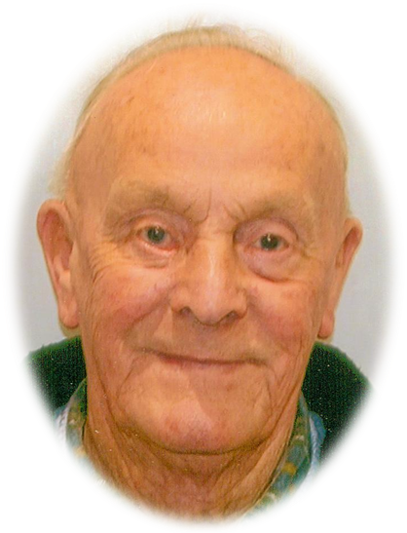

George Clarke

11th January 1926 – 27th February 2010

Tuesday 9th March 2010
at Walton Lea

Order of Service

Introduction

All: Merciful Father, hear our prayers and comfort us; renew our trust in your Son, whom you raised from the dead; strengthen our faith that all who have died in the love of Christ will share in his resurrection; who lives and reigns with you, in the unity of the Holy Spirit, one God, now and for ever. Amen

The Ministry of the Word

Psalm 23

1 The Lord is my shepherd; therefore can I lack nothing.

2 He makes me lie down in green pastures
and leads me beside still waters.

3 He shall refresh my soul and guide me
in the paths of righteousness for his name’s sake.

4 Though I walk through the valley of the shadow of death,
I will fear no evil;
for you are with me; your rod and your staff, they comfort me.

5 You spread a table before me
in the presence of those who trouble me;
you have anointed my head with oil and my cup shall be full.

6 Surely goodness and loving mercy
shall follow me all the days of my life,
and I will dwell in the house of the Lord for ever.

Glory be to the Father, and to the Son,
and to the Holy Spirit:
As it was in the beginning, is now, and ever shall be:
world without end. Amen.
The Scriptural Reading (John 14. 1-6)

“Jesus said to his disciples: 'Do not let your hearts be troubled. Believe in God, believe also in me. In my Father's house there are many dwelling places. If it were not so, would I have told you that I go to prepare a place for you? And if I go and prepare a place for you, I will come again and will take you to myself, so that where I am, there you may be also. And you know the way to the place where I am going.' Thomas said to him, 'Lord, we do not know where you are going. How can we know the way?' Jesus said to him, 'I am the way, and the truth, and the life. No one comes to the Father except through me.'”

This is the word of the Lord
All: Thanks be to God

The Address

The Prayers:

Each section concludes:
Lord, in your mercy
All: hear our prayer.

God of mercy, entrusting into your hands all that you have made and rejoicing in our communion with all your faithful people, we make our prayers through Jesus Christ our Saviour. Amen.

The Lord’s Prayer

All: Our Father, who art in heaven, hallowed be thy name; thy kingdom come; thy will be done; on earth as it is in heaven. Give us this day our daily bread. And forgive us our trespasses, as we forgive those who trespass against us. And lead us not into temptation; but deliver us from evil. For thine is the kingdom, the power and the glory, for ever and ever. Amen

Commendation and Farewell

All: Heavenly Father, in your Son Jesus Christ you have given us a true faith and a sure hope. Strengthen this faith and hope in us all our days, that we may live as those who believe in the communion of saints, the forgiveness of sins and the resurrection to eternal life; through Jesus Christ our Lord. Amen.

Acknowledgement: Common Worship: Pastoral Services, material from which is included in this service, is copyright © The Archbishops’ Council (2000)

